## **1. Overview**

The Teacher Module has been updated to allow users to select a backdate and modify session timing within the session schedule.

**Merge Functionality**

### **Merge Functionality Overview**

The **Merge** feature allows teachers and admins to merge sessions with other sessions or sections. This functionality is particularly useful when a teacher is unavailable on a particular day.

### **Admin Section**

1. **Merge Option Availability:**
   * Admins can merge sessions if a teacher is unavailable on a specific day.
   * Once a session is merged, no further options are shown for that session.

Two options are available:

* **Merge with Previous** – The session will be merged with the previous session.
* **Merge with Next** – The session will be merged with the upcoming session.
* On the user side, the details of the teacher are displayed
* On the teacher's side, the teacher can change their password and profile photo.

1. **Automated Changes:**
   * If the admin changes the date of a session, the merged session's date is automatically updated.
   * If the admin shifts a session, the merged session is also automatically shifted.
   * If the admin realigns a session, the merged session is automatically realigned.

### **Teacher Section**

1. **Merge Sessions:**
   * Teachers can merge their sessions with other sessions or sections if they are unavailable.
   * Once a session is merged, it is marked as **"Done"** on the user side, and the status is updated accordingly.

### **User Section**

1. **Upcoming Sessions:**
   * Verify that upcoming sessions are correctly displayed in both the **Teacher** and **User** sections.
   * Users should be able to see the next session date along with all upcoming sessions.
2. **Merge Session Visibility:**
   * When a teacher merges a session, verify that the user can see the updated changes and session details.
3. **Multiple Batch Handling:**
   * If a user is signed up for two batches with different timings:
     + Only the first batch's session is shown in the list.
     + After completing the first session, the second batch's session is displayed.
4. **Same User with Group and 1-1 Sessions:**
   * If the same user is enrolled in both **Group** and **1-1** sessions, verify that:
     + Both sessions are displayed correctly in the **User Section**.
     + The functionality works as expected in the **Teacher Section**.

### **Verification Points**

1. Ensure that merged sessions are correctly reflected in both the **Teacher** and **User** sections.
2. Verify that automated changes (date, shift, realign) are applied to merged sessions.
3. Confirm that users can see updated session details after a merge.
4. Validate that multiple batch sessions are displayed in the correct order for users.
5. Ensure that Group and 1-1 sessions for the same user are displayed correctly in both sections.

## **A new tab, "Merge", has been added to both the Admin and Teacher sections.**

## **Functionality:**

## **In the Teacher Section, if a teacher is on leave, they can merge sessions.**

## **The merge functionality allows the teacher to combine sessions based on availability and scheduling requirements.**

## **Admin Section:**

## **Admins can also access the Merge Tab to manage or approve session merges when a teacher is on leave.**

## **Admins can ensure sessions are merged appropriately to maintain the schedule without disruptions.**

## **This feature ensures seamless session management and minimizes scheduling conflicts when teachers are unavailable**

## **2. Feature Update**

### **2.1 Change Date - This Session**

*(Note : Time slots of assigned teacher based on selected date)(NT)*

*Change with current date and Present Time*

*-***> Free date time**

* An admin can select a backdate for a session, but it must fall within the timeframe between the previous session date and the current session date.
* Admin can modify the **session timing** within the existing schedule.
* The changes will be reflected in the **session records.** **Batch Day Schedule**

### **2.2 UI Updates**

A new tab has been introduced for selecting session dates and times, with the following fields:

| **Tab Name** | **Functionality** |
| --- | --- |
| **Select Date** | Allows the admin to choose the date within the timeframe between the previous session date and the current session date. |
| **Select Time** | Allow the Admin to adjust the session time within the given date. |

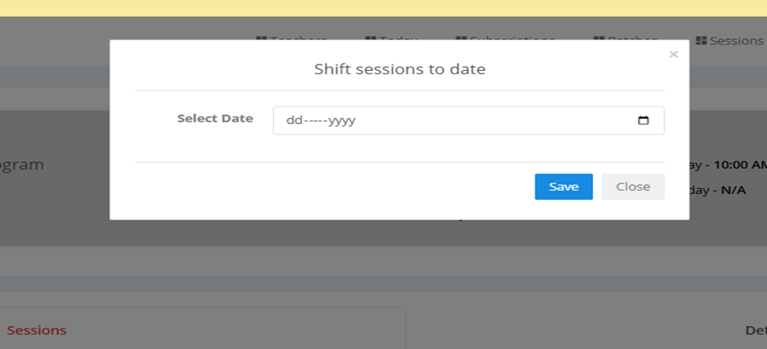

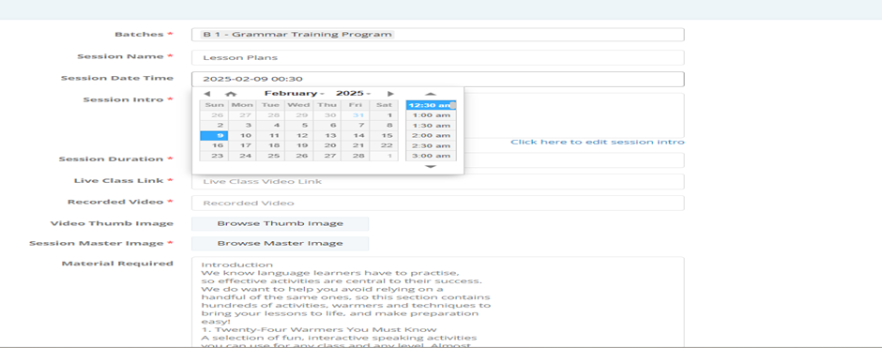

### **Realign Tab - Admin Controls**

**If the admin wants to change the batch, they should go to the Batch Tab. If the admin wants to modify a particular session, they should go to the Session Tab.**

**The admin can:0**

1. **Assign the same teacher but with a different time slot.**
2. **Assign a different teacher and a different time slot, depending on the availability of slots within that specific time frame.**

In this tab, the **Admin** can configure the following settings:

1. **Package Selection** – Admin can choose the package for the session.(Package can’t be change)
2. **Start Date & Time** – Admin can select the session start date and time. *(****Note: Backdating is not allowed in this tab.)***
3. **Select Teacher** – Admin can assign a teacher to the session.
4. **Time Slot Selection** – Admin can set the time slot for the session.

If admin want to change the session date then it must change the after the select date

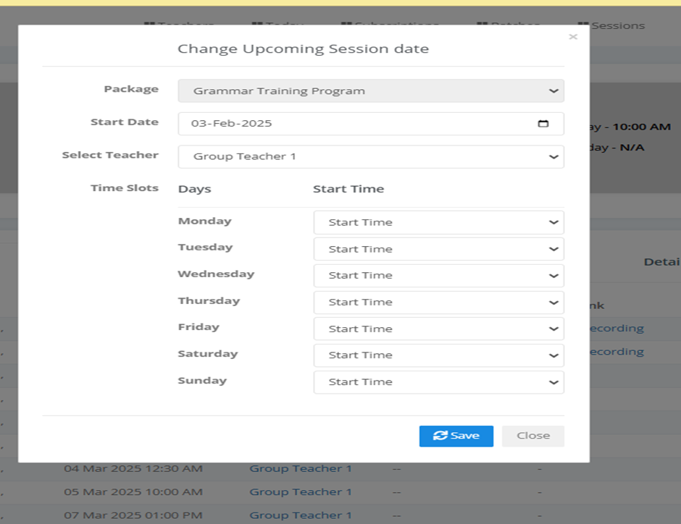

**\* Batch Update \***

When the **Admin creates a batch**, the system must **require** the following fields as **mandatory inputs**:

✅ **Batch Master Image**

✅ **Batch Filter Icon**

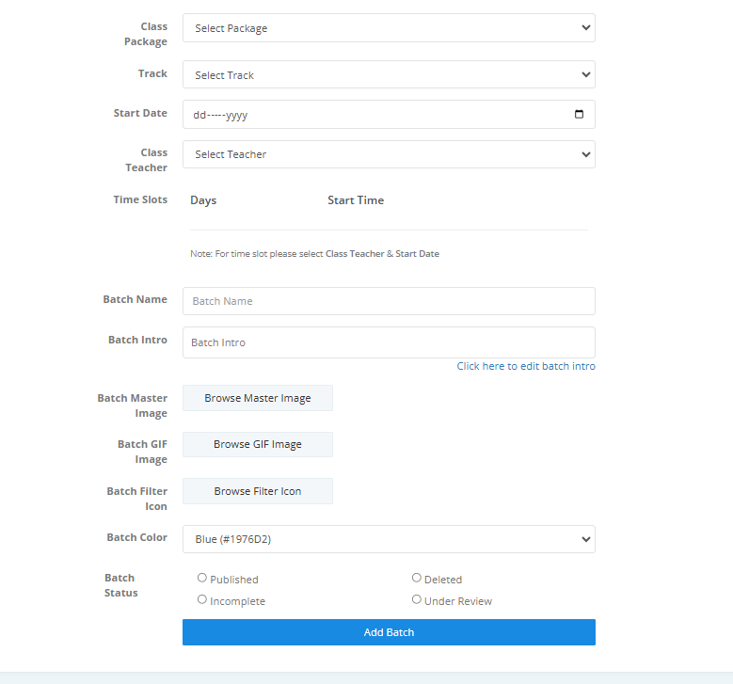

### **Tab Updates for Admin & Teacher**

#### **Tabs Removed:**

* **Shift End Session**
* **Shift Next Date**

#### **Final Tab Structure:**

✅ **Admin Panel:**

1. **Shift - Next Session**
2. **Change Date - This Session**
3. **Realign**
4. **Merge with Previous**
5. **Merge with Next**

✅ **Teacher Panel:**

1. **Shift - Next Session**
2. **Change Date - This Session**
3. **Merge with Previous**
4. **Merge with Next**